Platinum Import Procedure

- Move G/L & Original A/R
- From the start menu, choose Programs: GIS: Accounting File Mover (Short Cut).
- Select the RBR date you want to import from the list.
- Click on the Next button.
- Check that the arrow is pointing to All G/L & Original A/R Invoices.

- Import G/L transactions
- From the Start menu, choose Programs=> E by Epicor=>eBackOffice
- Log in with the special account (id:arvic/password:vicar).
- From the Import menu, choose GL Import: GL Transactions.
- Select “01_ImportGISGL” from the list.
- Click on the Process button and wait for the report.
- Check that the report lists 1 correct transaction and 0 wrong transactions.
- Close the report window. (You don’t need to save the results.)

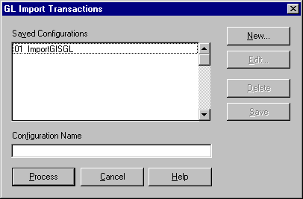
(Figure 1-1)

- Post G/L transactions
- From the Applications menu, choose General Ledger.
- From the Processing menu, choose Standard Transactions: Post Standard Transactions.
- Select “GIS IMPORTED” in the Journal Selection box and click the Add button.
- Click the Post button and wait for the report.
- Close the report window. (You don’t need to save the results.)
- From the File menu, choose Print.
- Close the report window. (You don’t need to save the results.)
- Close the General Ledger application.

- Import A/R original invoices (See Figure 1-2)
- From the Import menu, choose AR Import: AR Invoices/Credit Memos.
- Select “01_ ImportGISInvoiceOrg” from the list.
- Click on the Process button and wait for the report.
- Print the report to printer by clicking the printer button.
- Check that the report does not contain any errors.
- Close the report window. (You don’t need to save the results.)

- Import A/R original credit notes (See Figure 1-2)
- From the Import menu, choose AR Import: AR Invoices/Credit Memos.
- Select “02_ ImportGISCreditOrg” from the list.
- Click on the Process button and wait for the report.
- Print the report to printer by clicking the printer button.
- Check that the report does not contain any errors.
- Close the report window. (You don’t need to save the results.)

- Post A/R original invoices
- From the Application menu, choose Accounts Receivable
- From the Processing menu, choose Invoices: Post invoices
- Click the Post button and wait for the report.
- Close the report window. (You don’t need to save the results)

- Post A/R original credit memos
- From the Processing menu, choose Credit Memos: Post Credit Memos
- Click the Post button and wait for the report.
- Close the report window. (You don’t need to save the results)
- Close the Account Receivable Application

- Move A/R adjustment files to Platinum’s import directory.
- Switch windows to the Accounting File Mover
- Click the Next button
- Check that the arrow is pointing to A/R Adjustments.

- Import A/R adjustment invoices (See Figure 1-2)
- From the Import menu, choose AR Import: AR Invoices/Credit Memos.
- Select “03_ ImportGISInvoiceAdj” from the list.
- Click on the Process button and wait for the report.
- Print the report to printer by clicking the printer button.
- Check that the report does not contain any errors.
- Close the report window. (You don’t need to save the results.)

- Import A/R adjustment credit notes (See Figure 1-2)
- From the Import menu, choose AR Import: AR Invoices/Credit Memos.
- Select “04_ ImportGISCreditAdj” from the list.
- Click on the Process button and wait for the report.
- Print the report to printer by clicking the printer button.
- Check that the report does not contain any errors.
- Close the report window. (You don’t need to save the results)
- Close the Accounts Receivable application.

- Post A/R original invoices
- From the Application menu, choose Accounts Receivable
- From the Processing menu, choose Invoices: Post invoices
- Click the Post button and wait for the report.
- Close the report window. (You don’t need to save the results)

- Post A/R original credit memos
- From the Processing menu, choose Credit Memos: Post Credit Memos
- Click the Post button and wait for the report.
- Close the report window. (You don’t need to save the results)
- Close the Account Receivable Application

- Post A/R to GL
- From the Application menu, choose General Ledger
- From GL Processing menu, choose Standard Transactions: Post Standard Transactions
- From Post Standard Transaction menu, choose Account Receivable and add it into Select Journal box
- Click the Post button and wait for the report.
- Close the report window. (You don’t need to save the results)

- Print the GL Balancing Report
- From the Applications menu, choose General Ledger.
- From the Reports menu, choose General Ledger.
- Select “GIS Import Control Account”.(1185-00-00 A/R Clearing Account)
- Click the process button.
- Select “Summary”.
- Click the ok button.
- Enter the “Begin Period” and “Through Period” dates.
- Click the ok button and wait for the report.
- Print the report to printer by clicking the printer button.
- Close the report window. (You don’t need to save the results)
- Close the General Ledger application.
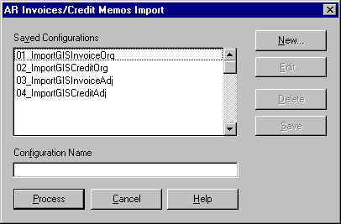
(Figure 1-2)

